SYDNEY 1.5 Regular grid land-sea mask

|  |  |  |  |  |  |  |  |
| --- | --- | --- | --- | --- | --- | --- | --- |
| Setup | IMETHOD | OFFSETX | OFFSETY | LAND_FRAC | MIN_ADJACENT | MIN_LAKE_FRAC | OK? |
| C2 (CAP 8.5) | 4 | 1 | 1 | 0.5 | 2 | 2 | No |
| C2a (CAP9.1) | 4 | 1 | 1 | 0.5 | 2 | 2 | No |
| C2b | 5 | 1 | 1 | 0.5 | 2 | 2 | No, xoffset not enough |
| C2c | 5 | 2 | 1 | 0.5 | 2 | 2 | Ditto |
| C2d | 5 | 2 | 1 | 0.4 | 2 | 2 |  |
| C2e | 5 | 2 | 1 | 0.3 | 2 | 2 |  |
| C2f | 5 | 2 | 1 | 0.2 | 2 | 2 |  |
| C2g | 5 | 2 | 1 | 0.5 | 1 | 2 | Issues with Sydney, Ulladulla, Batesman Bay, north Nelson Bay, Jervis Bay |
| C2h | 5 | 2 | 1 | 0.4 | 1 | 2 | Sydney better, Ulladula as bad, Jervis Bay as bad, Hornsby looks good |
| C2i | 5 | 2 | 1 | 0.3 | 1 | 2 | Offsety may be too much, Sydney river cutoff |
| C2j | 5 | 2 | 1 | 0.2 | 1 | 2 | NO, too much coastal land points |
| C2k | 5 | 2 | 0 | 0.5 | 2 | 2 | Ulladulla looks poor, Hornsby needs editing, Sydney river needs more land points |
| C2l | 5 | 2 | 0 | 0.4 | 2 | 2 | OK, Ulladulla need edits, |
| C2m | 5 | 2 | 0 | 0.3 | 2 | 2 | Too much river land points? |
| **C2n** | **5** | **2** | **0** | **0.4** | **2** | **0.5** | **OK, Hornsby need edits** |
| C2o | 5 | 2 | 0 | 0.3 | 2 | 0.5 | May be too much land points |

C2l and C2n serve as a good starting point; we will use C2n because the inland lake in Jervis Bay is better represented.

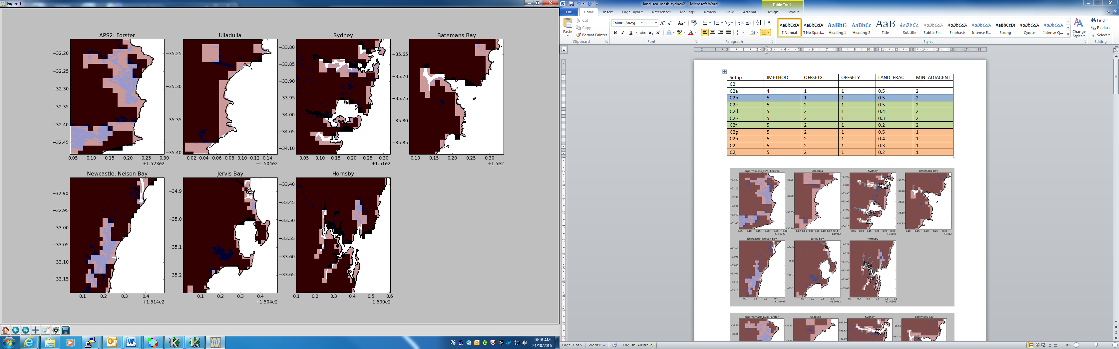

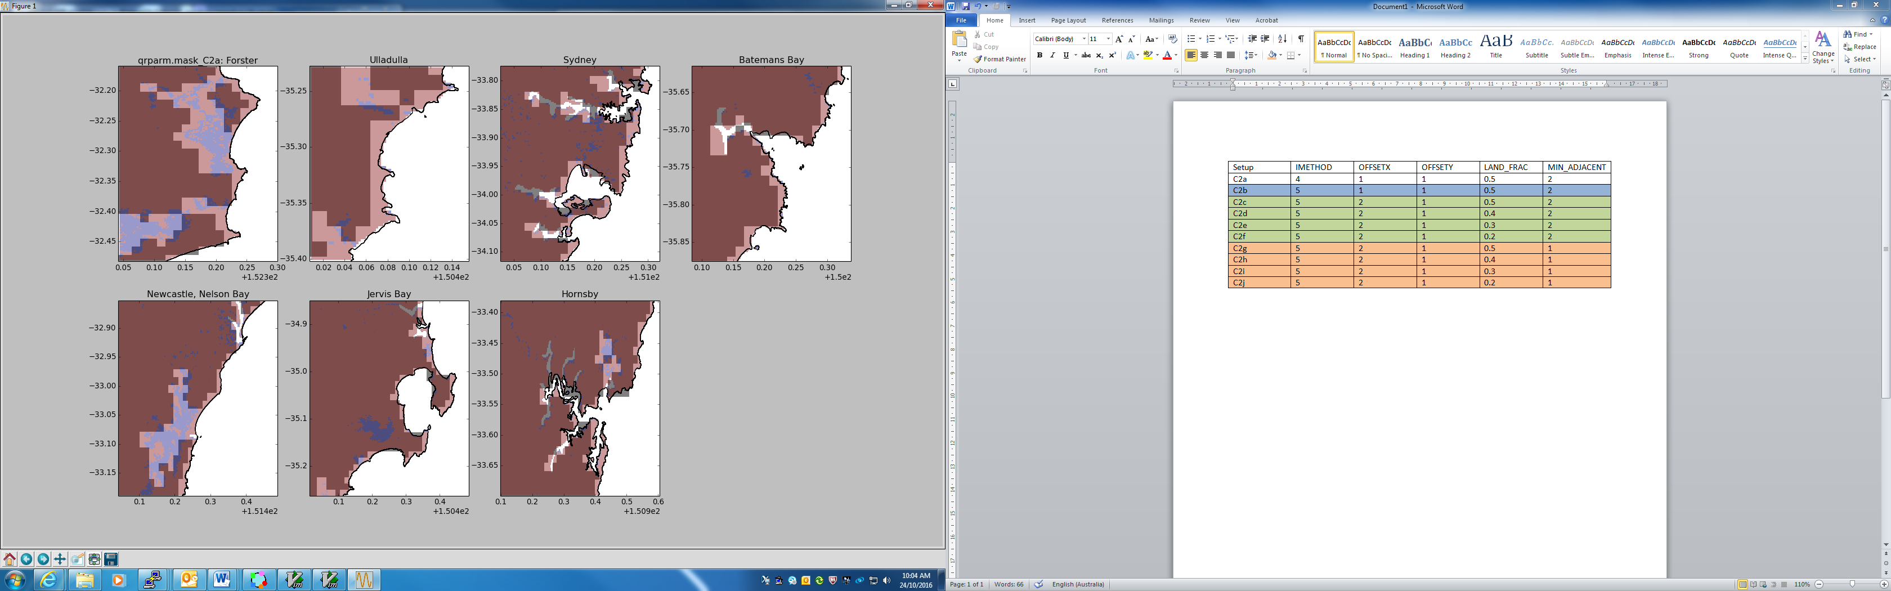

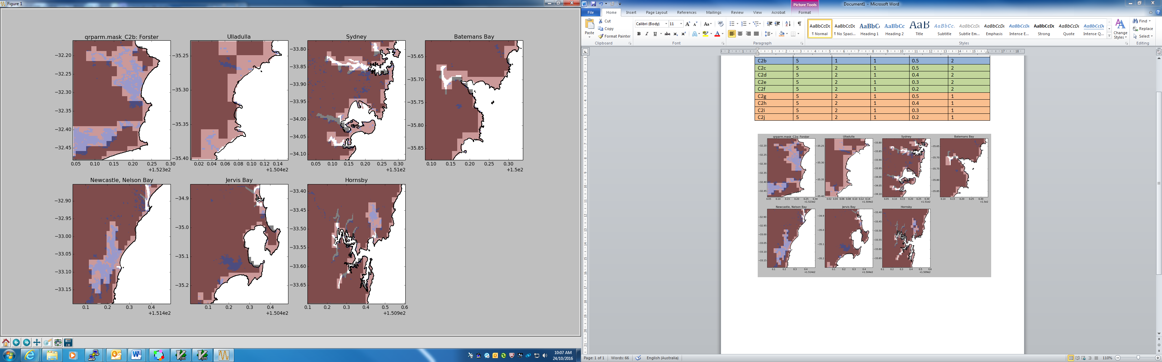

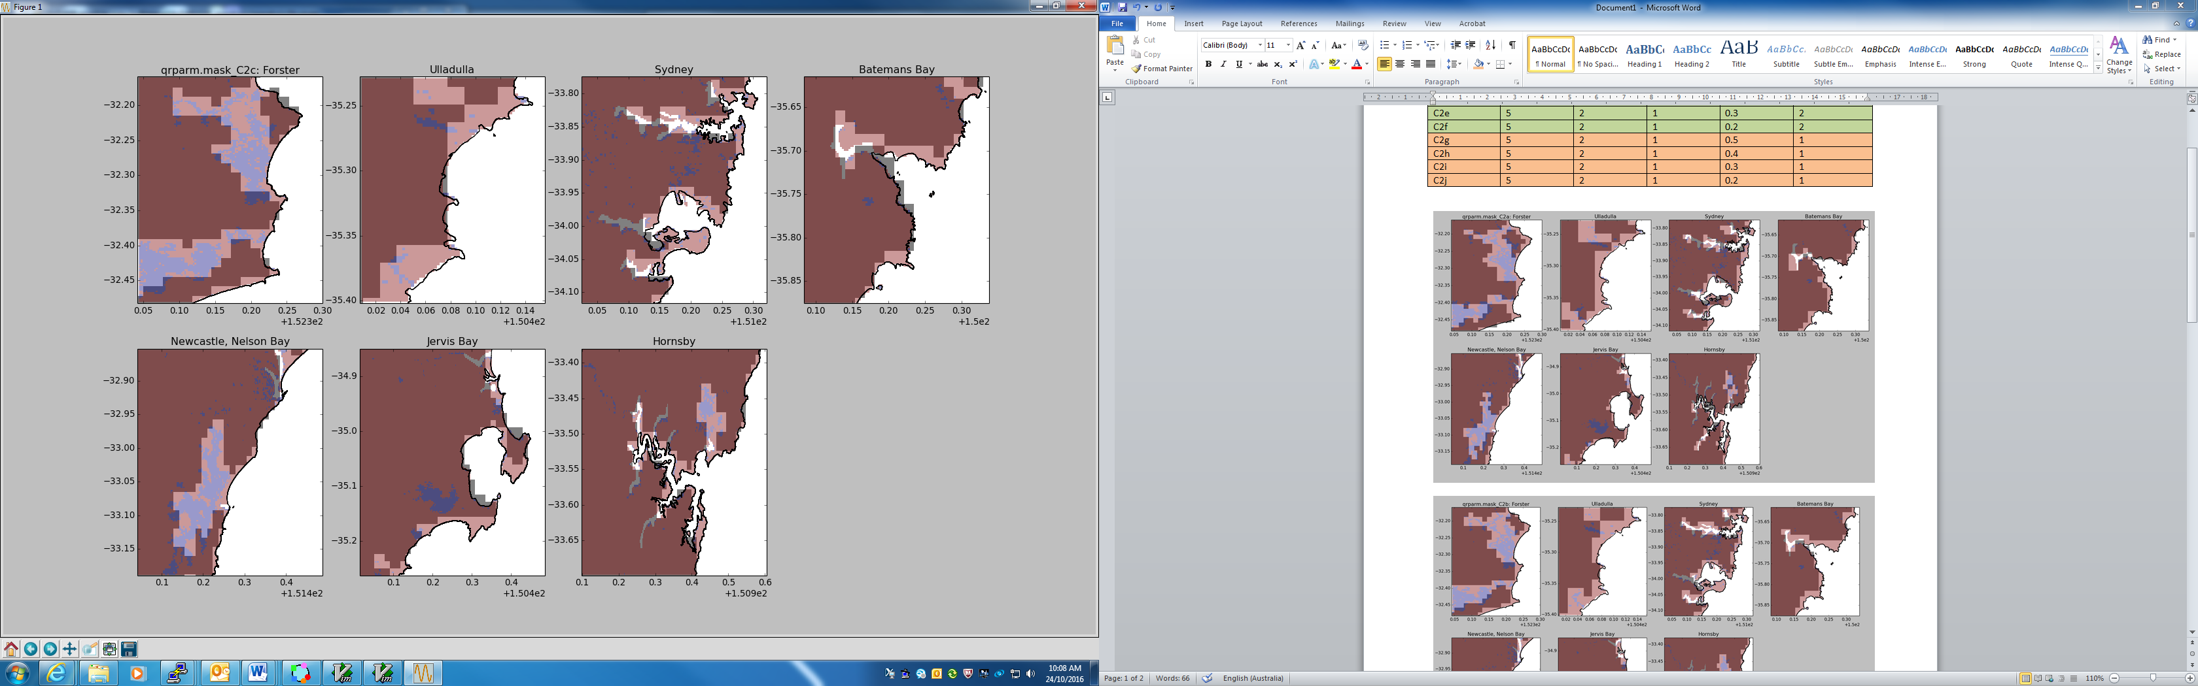

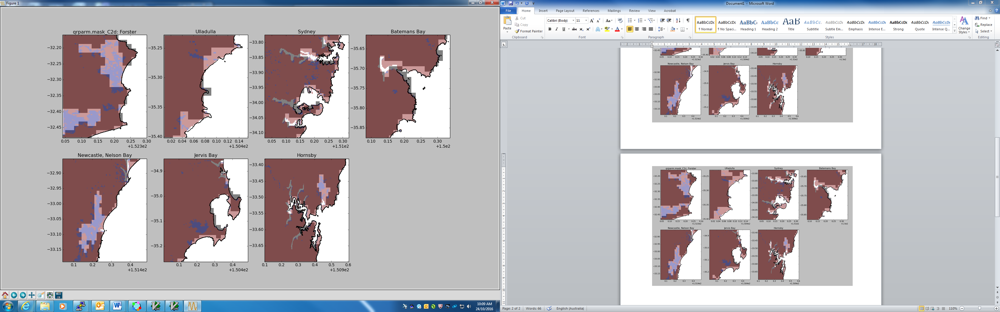

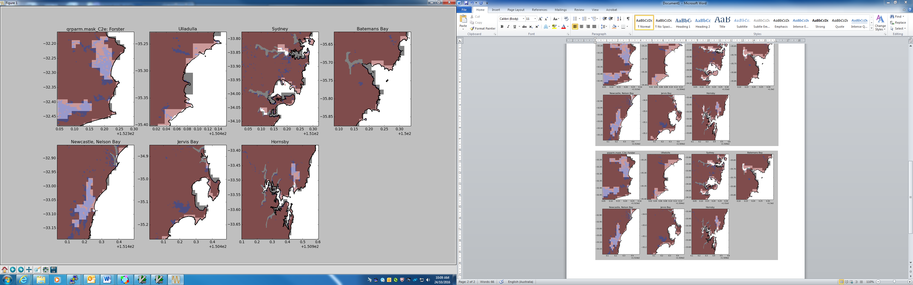

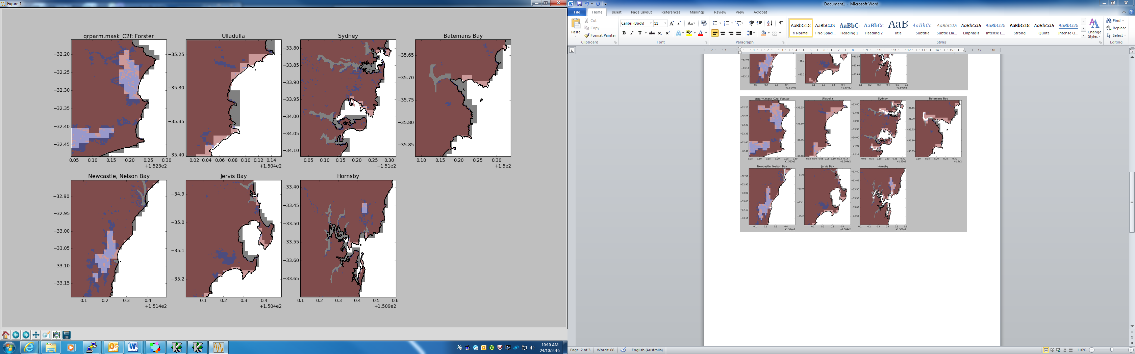

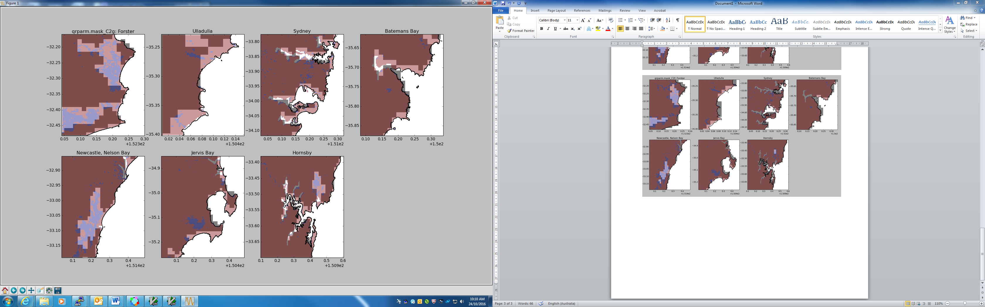

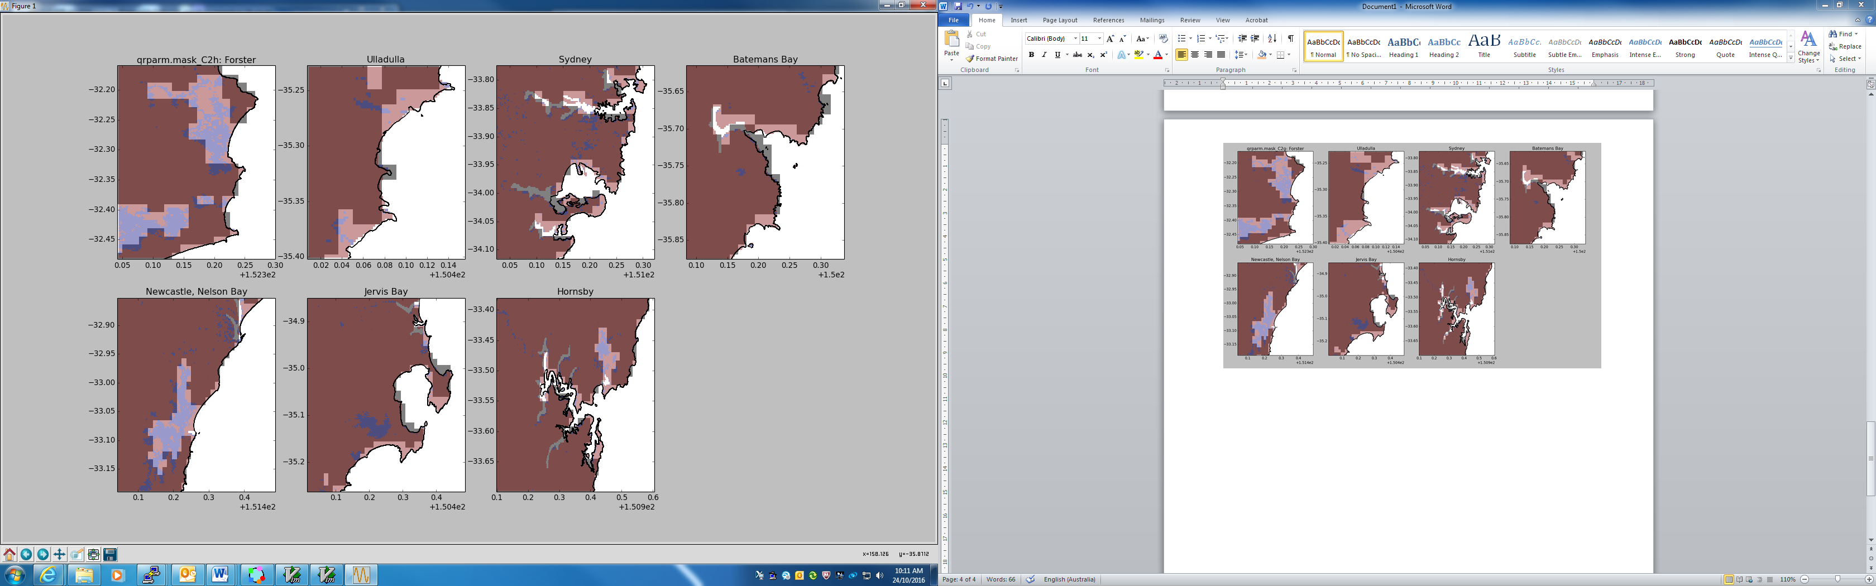

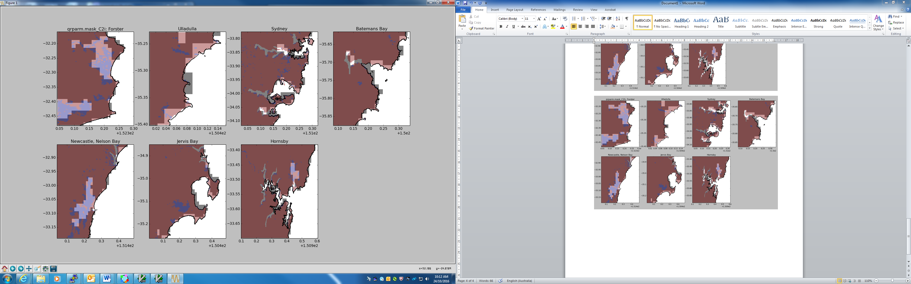

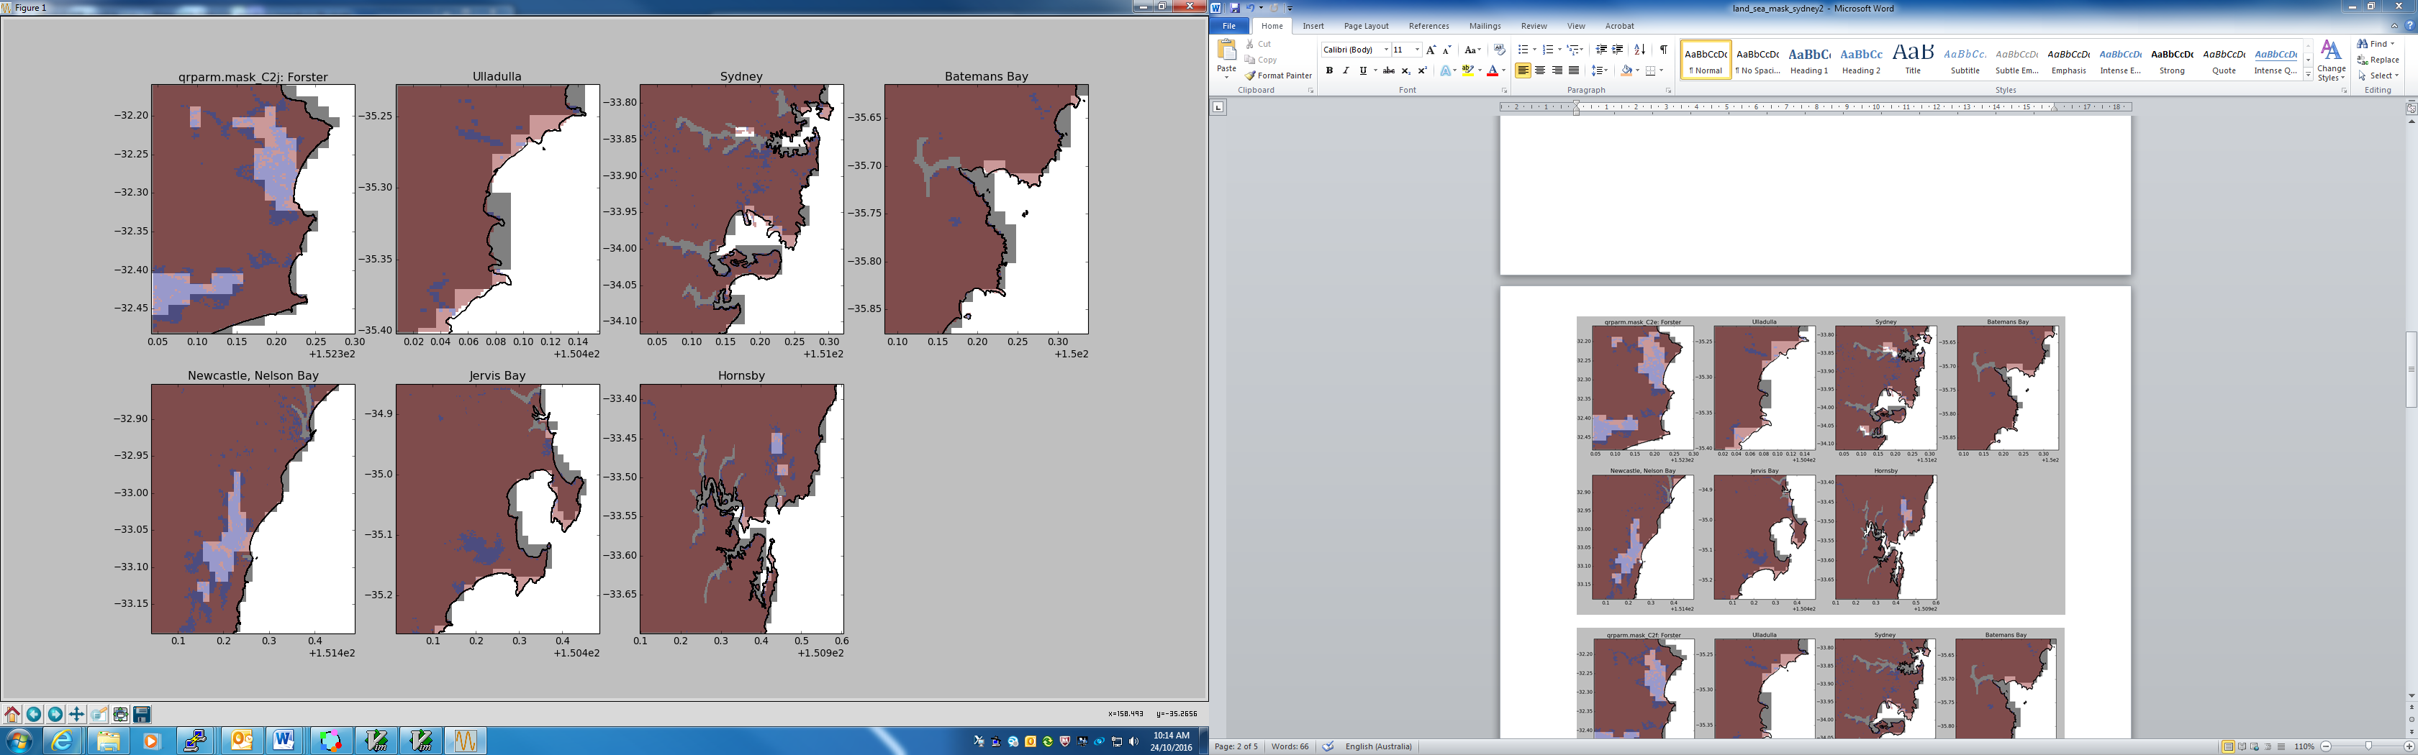

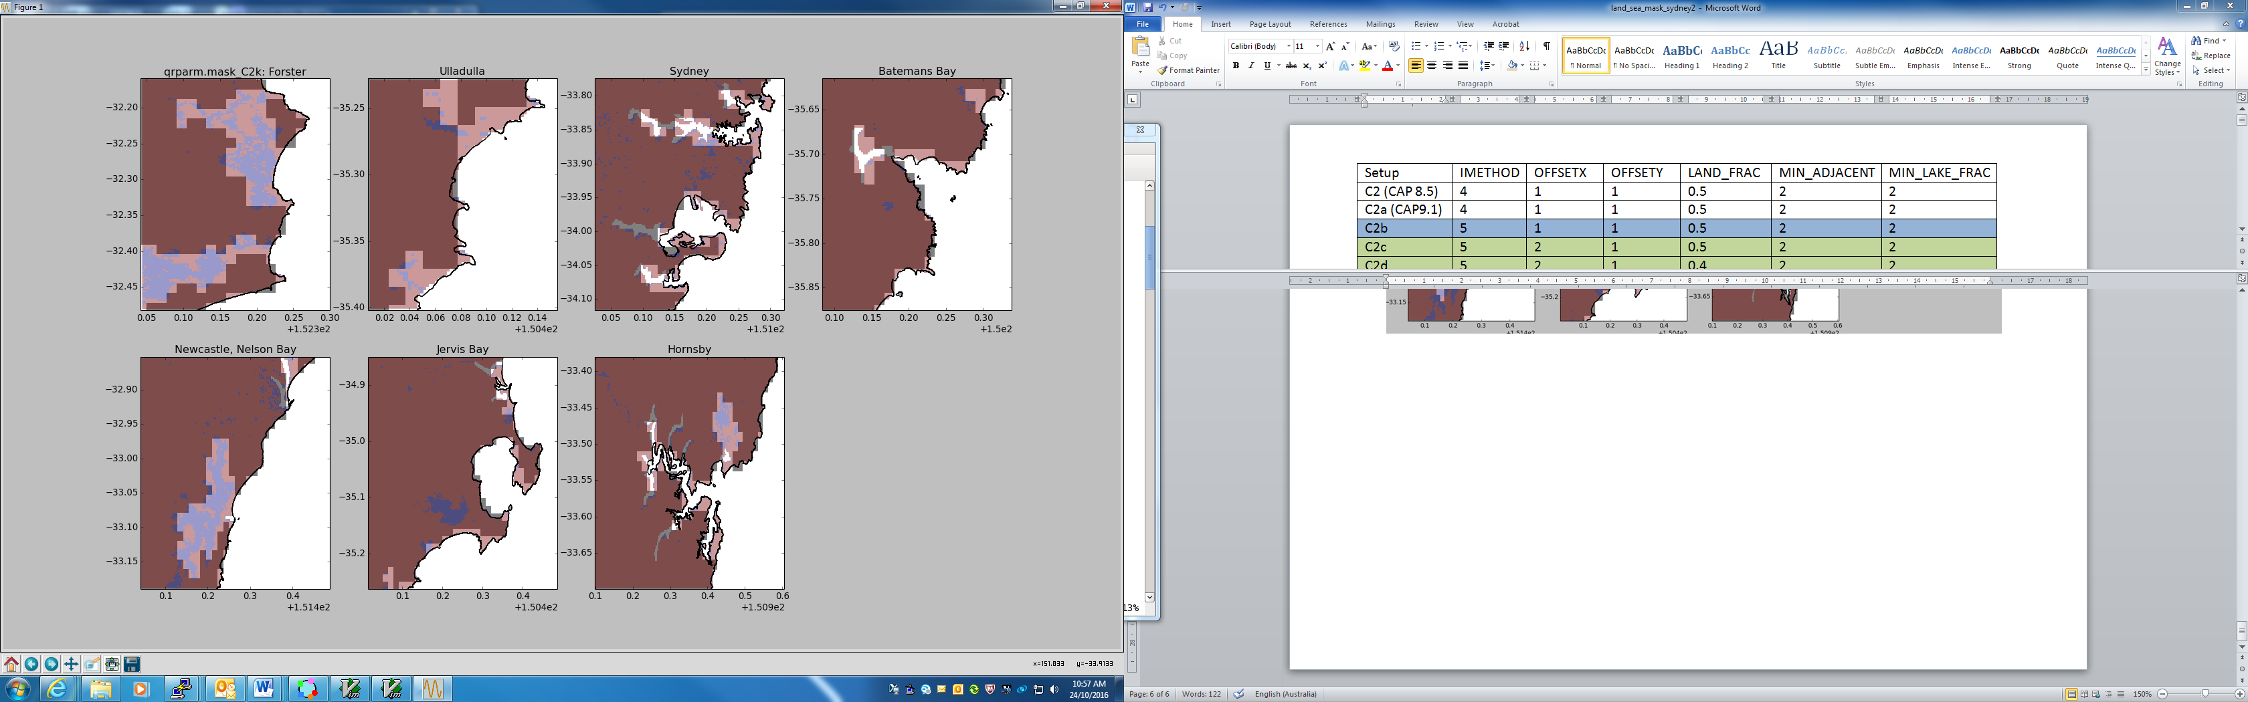

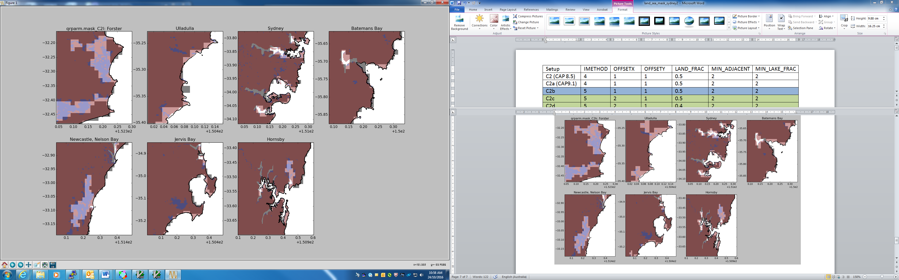

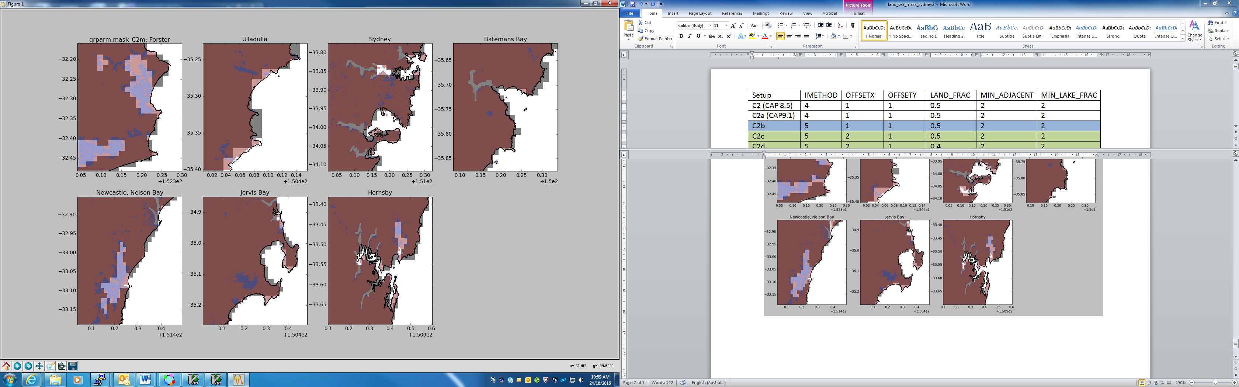

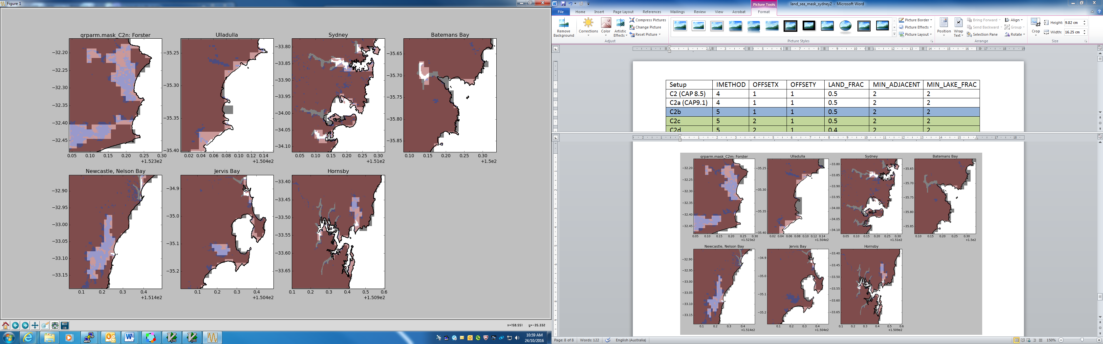

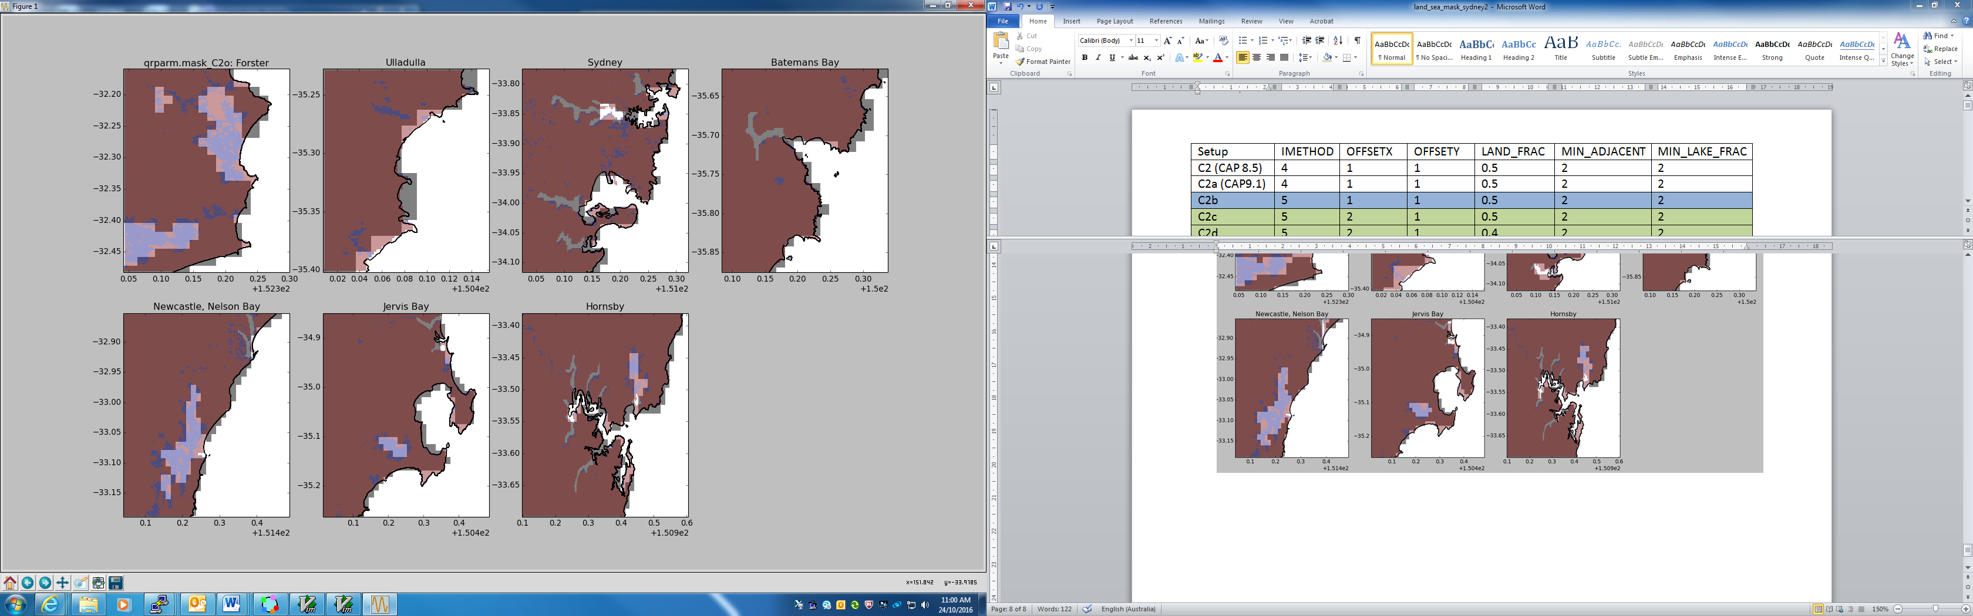

C2n setting + mask_changes.nl with loverride=true:

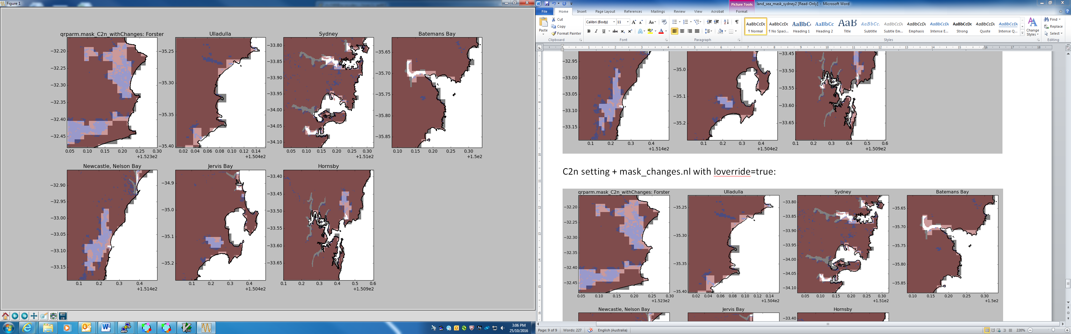

TASMANIA 1.5 Regular grid land-sea mask

APS-2 VT land sea mask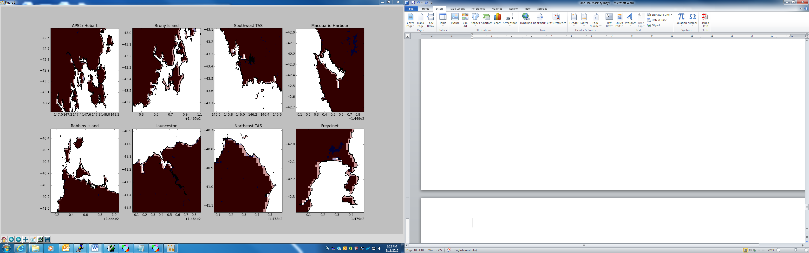

Modified land sea mask using setting in C2n setting without mask_changes (see above):

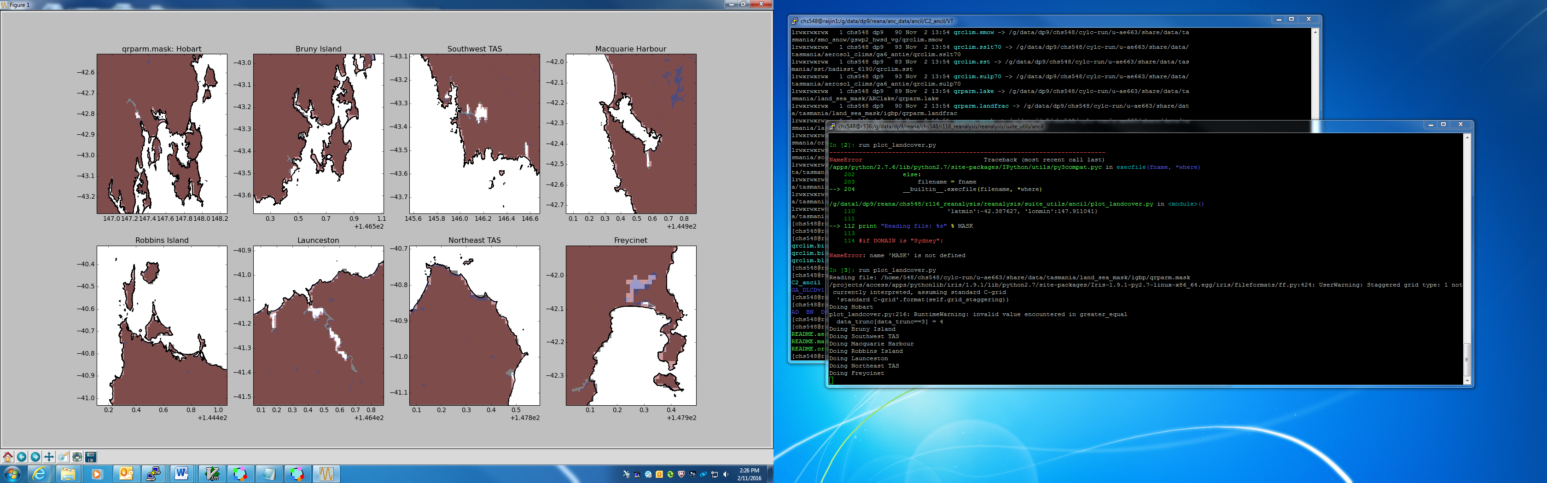

REGIONAL DOMAIN 12km Regular grid land-sea mask

